Attending your appointment via video

5 -19 yrs - School Health Team Central – Sefton Waiting Area.

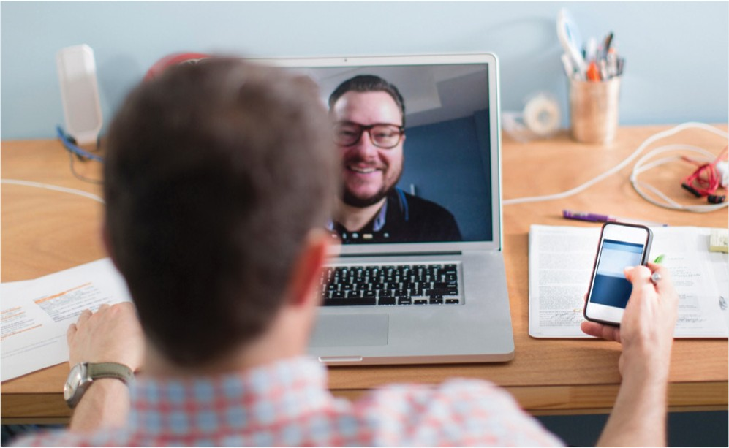
Instead of travelling to your appointment, you enter the clinic’s online waiting area. The health service is notified when you arrive, and your clinician will join you when ready.

Where do I go to attend my appointment?
Go to: https://nhs.vc/schoolnursesseftonmaghull

Where appropriate, you can attend your consultation online via a video call.
Video calling is as convenient as a phone call, with the added value of face-to-face communication.
It can save you time and money, and brings your care closer to home.
There is no need to create an account. No information you enter is stored.
What do I need to make a video call? A good connection to the internet
If you can watch a video online (e.g. YouTube) you can make a video call
A private, well-lit area where you will not be disturbed during the consultation
One of these:
Google Chrome web browser on a desktop or laptop, or on an Android tablet or smartphone
Smartphone and tablet users
If you can, connect to a home or work Wi-Fi network to avoid using your mobile data allowance.
Safari web browser on an Apple iMac, MacBook, iPad, or iPhone
Web-camera, speakers and microphone already built into laptops or mobile devices
Is it secure?
Video calls are secure; your privacy is protected.
You have your own private video room that only authorised clinicians can enter.

How much internet data will I use?
You don’t use any data while waiting for a clinician to join you.
A video call uses a similar amount of data to Skype® or FaceTime®.

How much does a video call cost?
The video call is free
(except for your internet usage).

See over for more information on how to make a video call

Get ready to make video calls
Make sure that you use one of the following web browsers
Google Chrome
Windows 7+, Android 5.1+, MacOS
10.11+, iPadOS 13+
Apple Safari
MacOS 10.12+, iOS 11.4+, iPadOS 13+

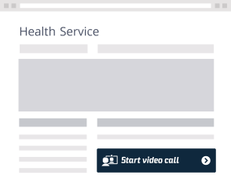
On this web page, click the Start video call button and follow instructions
Go to: https://nhs.vc/schoolnursesseftonmaghull
Wait in your own private video room
Your healthcare provider sees you arrive in the waiting area queue...

...and joins you in your video room when they are ready

What do I do if something is not working?
Visit https://england.nhs.attendanywhere.com/troubleshooting
More information
Visit https://nhs.attendanywhere.com/callers

