bs02092_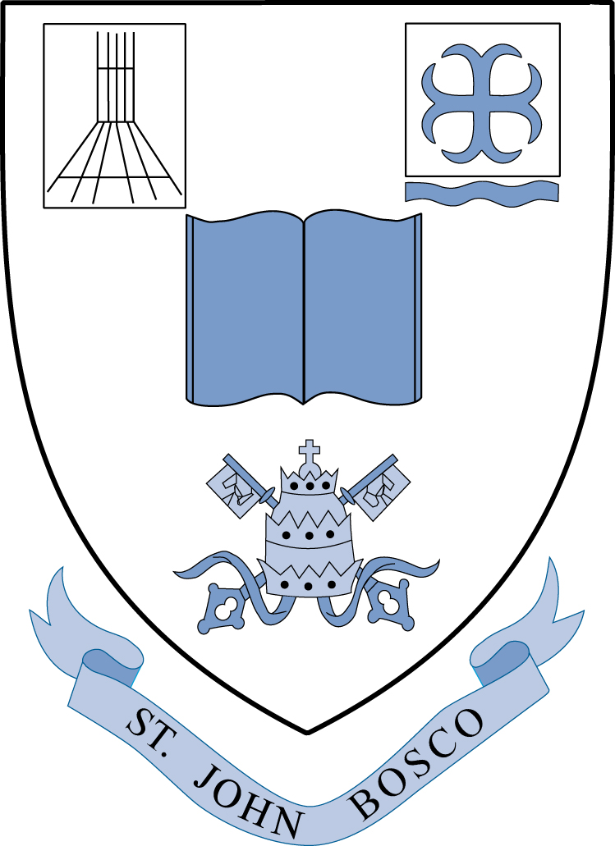*St John Bosco Catholic Primary School*

*Green Lane, Maghull L31 8BW*

*Tel/Fax: 0151.520.2628*

*Headteacher: Mr D MacAreavy Bed (Hons), CTC, NPQH*

3rd May 2022

Dear parents,

As you will be aware, next week the Year 6 children will complete their end of key stage 2 (SATS) examination tests. The children have been working incredibly hard towards this week and I am confident that they are ready to do their best in all of the tests they complete.

In order to ensure that your child is settled before the tests begin, we would appreciate it if they could arrive at school at 8.30am and come straight into the Year 6 classroom. Here, they will be provided with fresh fruit (although I would advise they still have a normal breakfast at home) and be given the opportunity to remind them of things they need to remember when completing the tests.

The structure of the week is as follows:

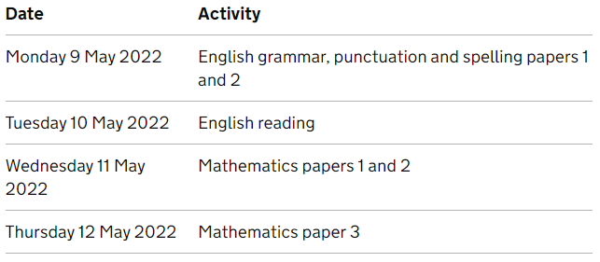

I would ask, in order to ensure that your child can perform to the best of their ability, that during the weekend and for the following week, they are well rested. If children are tired, they will find it difficult to concentrate, so a sensible bedtime will give them every advantage.

Kind regards,

Mr. Mainwaring / Mrs. Bretherton

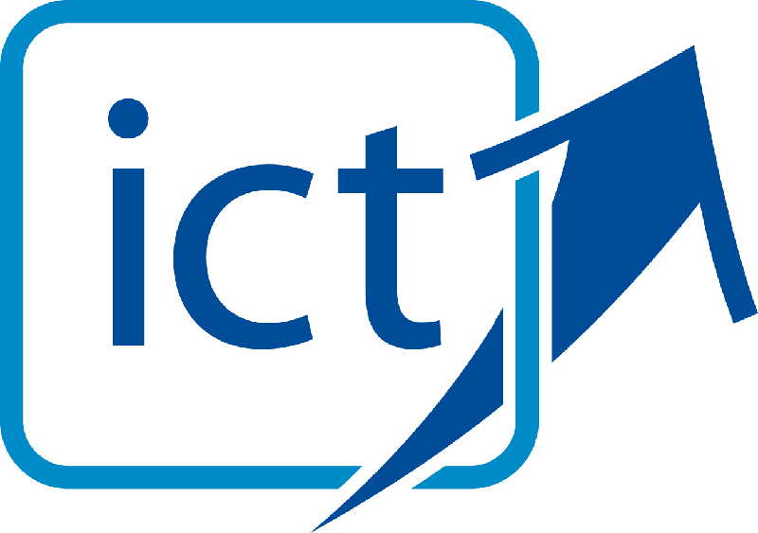http://www.stjohnboscoprimary.co.uk/Images/healthyschoolslogosmall.jpg